**CA 2**

**HARIHARAN T**

**727721EUIT046**

**1.)**

package com.selenium.test2.selenium1;

import org.testng.annotations.Test;

import org.testng.AssertJUnit;

import org.openqa.selenium.By;

import org.openqa.selenium.Keys;

import org.openqa.selenium.WebDriver;

import org.openqa.selenium.WebElement;

import org.openqa.selenium.chrome.ChromeDriver;

import org.openqa.selenium.chrome.ChromeOptions;

import io.github.bonigarcia.wdm.WebDriverManager;

public class ca2 {

public static void main(String[] args) throws InterruptedException {

WebDriverManager.*chromedriver*().setup();

ChromeOptions co=new ChromeOptions();

co.addArguments("--remote-allow-origins=*");

WebDriver d=new ChromeDriver(co);

d.get("https://www.trivago.in/");

d.manage().window().maximize();

String actualTitle=d.getTitle();

System.***out***.println("Page title is : " + d.getTitle());

String expectedTitle = "trivago.in - Compare hotel prices worldwide";

if(actualTitle.equalsIgnoreCase(expectedTitle))

System.***out***.println("Title Matched");

else

System.***out***.println("Title didn't match");

Thread.*sleep*(4000);

WebElement place=d.findElement(By.*xpath*("//*[@id=\"input-auto-complete\"]"));

place.click();

place.sendKeys("Chennai",*Keys*.***ENTER***);

Thread.*sleep*(2000);

WebElement click=d.findElement(By.*xpath*("//*[@id=\"suggestion-list\"]/ul/li[1]/div"));

click.click();}

*@Test*

public void f()throws InterruptedException {

WebDriverManager.*chromedriver*().setup();

WebDriver driver;

ChromeOptions co = new ChromeOptions();

co.addArguments("--remote-allow-origins=*");

driver=new ChromeDriver(co);

driver.manage().window().maximize();

driver.get("https://www.trivago.in/");

Thread.*sleep*(2000);

String actualTitle="trivago.in - Compare hotel prices worldwide";

String extractedTitle=driver.getTitle();

AssertJUnit.*assertEquals*(actualTitle, extractedTitle);

System.***out***.println("Page title is Validated.");

Thread.*sleep*(2000);

WebElement location=driver.findElement(By.*xpath*("//*[@id=\"__next\"]/div[1]/div[1]/section/div[2]/div[3]/div/div[1]/div/form/div"));

location.click();

Thread.*sleep*(2000);

WebElement ben=driver.findElement(By.*xpath*("//*[@id=\"suggestion-list\"]/ul/li[1]/div/div"));

ben.click();

Thread.*sleep*(2000);

WebElement cin=driver.findElement(By.*xpath*("//*[@id=\"__next\"]/div[1]/div[1]/section/div[2]/div[3]/div/div[2]/div/div/div/div[2]/div/div[1]/div[2]/button[2]/time"));

cin.click();

Thread.*sleep*(2000);

// WebElement coutcol=driver.findElement(By.xpath("//*[@id=\"__next\"]/div[1]/div[1]/section/div[2]/div[3]/div/div[1]/fieldset/button[2]/span"));

// coutcol.click();

WebElement cout=driver.findElement(By.*xpath*("//*[@id=\"__next\"]/div[1]/div[1]/section/div[2]/div[3]/div/div[2]/div/div/div/div[2]/div/div[1]/div[2]/button[7]/time"));

cout.click();

Thread.*sleep*(2000);

WebElement inc=driver.findElement(By.*xpath*("//*[@id=\"__next\"]/div[1]/div[1]/section/div[2]/div[3]/div/div[2]/div/div/div[1]/div/div[1]/div[1]/div/button[2]/span/span[1]"));

inc.click();

inc.click();

inc.click();

Thread.*sleep*(2000);

WebElement pet=driver.findElement(By.*id*("checkbox-13"));

pet.click();

Thread.*sleep*(3000);

WebElement apply=driver.findElement(By.*xpath*("//*[@id=\"__next\"]/div[1]/div[1]/section/div[2]/div[3]/div/div[2]/div/div/div[2]/div/button[2]"));

apply.click();

Thread.*sleep*(3000);

if(driver.getTitle().equals("Bengaluru (Pet friendly) Hotels | Find & compare great deals on trivago")) {

System.***out***.println("1.Verified that the user can enter the location of stay.");

System.***out***.println("2.Verified that the user can select the check-in and check-out date.");

System.***out***.println("3.Verified that the user can enter the no of rooms based on their preference.");

}

}

}

**Output:**

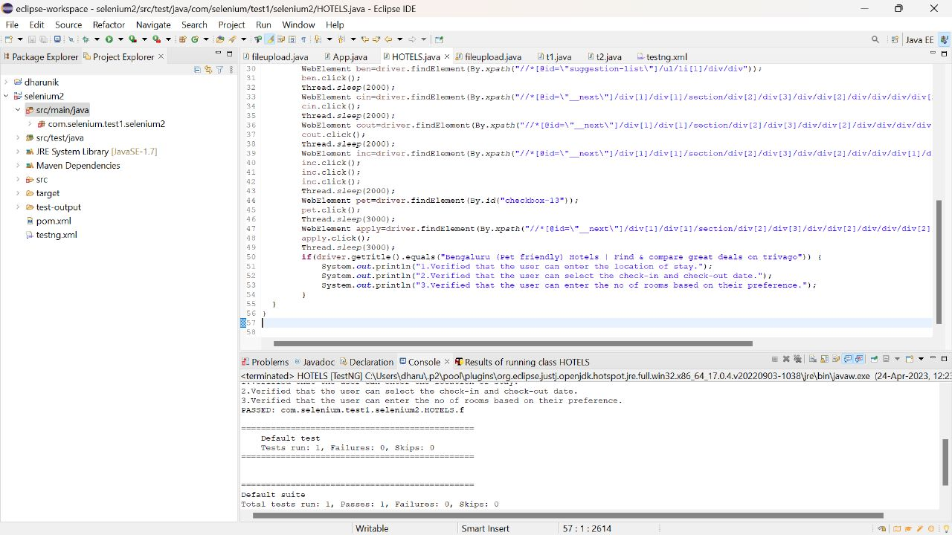

**2.)**

package com.selenium.test1.selenium1;

import org.openqa.selenium.By;

import org.openqa.selenium.WebDriver;

import org.openqa.selenium.WebElement;

import org.openqa.selenium.chrome.ChromeDriver;

import org.openqa.selenium.chrome.ChromeOptions;

import io.github.bonigarcia.wdm.WebDriverManager;

public class CA2{

public static void main(String[] args) throws InterruptedException {

// Set up the Chrome driver

WebDriverManager.chromedriver().setup();

ChromeOptions co=new ChromeOptions();

co.addArguments("--remote-allow-origins=*");

WebDriver driver=new ChromeDriver(co);

driver.get("https://www.saucedemo.com/inventory.html");

driver.manage().window().maximize();

// Log in with a valid username and password

WebElement usernameField = driver.findElement(By.id("user-name"));

WebElement passwordField = driver.findElement(By.id("password"));

WebElement loginButton = driver.findElement(By.id("login-button"));

usernameField.sendKeys("standard_user");

passwordField.sendKeys("secret_sauce");

Thread.sleep(3000);

loginButton.click();

// Add a product to the cart

WebElement addToCartButton = driver.findElement(By.id("add-to-cart-sauce-labs-backpack"));

addToCartButton.click();

Thread.sleep(3000);

// Verify that the product was added to the cart

WebElement cartBadge = driver.findElement(By.id("remove-sauce-labs-backpack"));

String t=cartBadge.getText();

if(t.equals("Remove")) {

System.out.println("1. Item is Added to Cart");

}

// View the contents of the cart

WebElement cartLink = driver.findElement(By.className("shopping_cart_badge"));

cartLink.click();

WebElement cart = driver.findElement(By.className("title"));

String a=cart.getText();

if(a.equals("Your Cart")) {

System.out.println("2. Your Cart is Viewed");

}

Thread.sleep(3000);

// Verify that the checkout form is displayed

WebElement checkoutButton = driver.findElement(By.id("checkout"));

checkoutButton.click();

WebElement check= driver.findElement(By.className("title"));

String b=check.getText();

if(b.equals("Checkout: Your Information")) {

System.out.println("3. Your Information Form is Displayed");

}

Thread.sleep(3000);

// Fill out the checkout form and product overview should be displayed

WebElement firstNameField = driver.findElement(By.id("first-name"));

WebElement lastNameField = driver.findElement(By.id("last-name"));

WebElement postalCodeField = driver.findElement(By.id("postal-code"));

WebElement continueButton = driver.findElement(By.cssSelector(".btn_primary.cart_button"));

firstNameField.sendKeys("John");

lastNameField.sendKeys("Doe");

postalCodeField.sendKeys("12345");

Thread.sleep(3000);

continueButton.click();

WebElement over= driver.findElement(By.className("title"));

String c=over.getText();

if(c.equals("Checkout: Overview")) {

System.out.println("4. Product Overview is Displayed");

}

Thread.sleep(3000);

//Name and price of the product should be displayed

WebElement productName = driver.findElement(By.xpath("//*[@id=\"item_4_title_link\"]/div"));

WebElement productPrice = driver.findElement(By.xpath("//*[@id=\"checkout_summary_container\"]/div/div[2]/div[8]"));

String name=productName.getText();

String price=productPrice.getText();

System.out.println("5. Product Name: "+name);

System.out.println(" "+price);

//Title and URL of the page

String tit=driver.getTitle();

if(tit.equals("Swag Labs")){

System.out.println("6. Title of the page is Correct");

}

String u=driver.getCurrentUrl();

if(u.equals("https://www.saucedemo.com/checkout-step-two.html")){

System.out.println("7. URL of the page is Correct");

}

}

}

Output:

